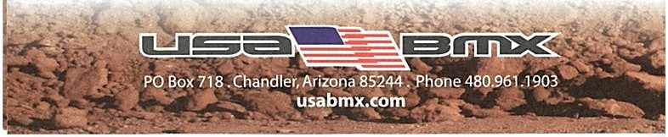
WEE-CHI-TAH BMX

502 Wichita St., Wichita Falls, TX 76308
FREE 1 DAY MEMBER SHIP
RACING SATURDAY
Sign-ups:2:00-3:00 pm I Racing:ASAP

PRACTICE TUESDAY & THURSDAY
5:00-7:00 pm

Mark Pinson:940-636-9014 Email:weechitahbmx@yahoo. com Web Site: weechitah.org Facebook: wee-chi-tah Bmx

